Writing to text files

# Code snippet .

Creates a new file called players.txt, writes two lines of text, closes the file

| 1  2  3 | file = open("players.txt", "w")  file.write("DinoShark\nMouseDragon\n")  file.close() |
| --- | --- |

Challenge 1 .Enter four player names

Create a program that performs the following:

* Prompts the user to enter four player names
* Allows the user to enter each name individually
* Once the names have been entered, the names should be written to a text file called players.txt
* Each player name should appear on a new line in the text file

**Example input/output**

| Enter player 1  Fred  Enter player 2  Wilma  Enter player 3  Barney  Enter player 4  Dino  >>> |
| --- |

**Example text file data**

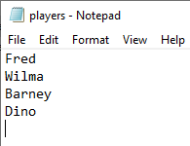

**Test your code then enter it below:**

|  |
| --- |

# Challenge 2 .Number cruncher

Create a program that performs the following:

* Prompts the user to choose between +, /, *, and -
* Prompts the user to enter a number
* Prompts the user to enter another number
* Calculates the two numbers based on their first choice
* Sends the answer to a text file called calculation.txt

**Tip**: Remember that data sent to a text file must be string

**Example input/output**

| Would you like to 1. add, 2. divide, 3. multiply or 4. subtract? Enter 1 to 4  2  Enter your first number  3  Enter your second number  3  >>> |
| --- |

**Example text file data**

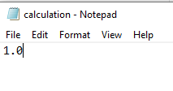

**Test your code then enter it below:**

|  |
| --- |

# Explorer task . Read the new text files

For each of the programs that you have just created, add in some extra code that will read and display the entire contents of the text files.

|  |
| --- |

# 